GROUP 21-11

**MATERNAL MORTALITY RATE PREDICTION AND ADVISORY SYSTEM**

Software Design Document

**Name (s)**: Kyanzi Hassan Musisi, Asiimwe Brenda Angel, Tindyebwa Fortunate Allan and Wamala Edgar Watson

**Lab Section:** College of Computing and Information Sciences, Software Engineering

**Workstation:** Makerere University

**Table of Contents**

1. INTRODUCTION 2

1.1 Purpose 2

1.2 Scope 2

1.2.1 Geographical Scope 2

1.2.2 Technical Scope 2

1.3 Overview 3

1.4 Reference Material 3

1.5 Definitions and Acronyms 4

2. SYSTEM OVERVIEW 4

3. SYSTEM ARCHITECTURE 6

3.1 Architectural Design 6

3.2 Decomposition Description 7

3.3 Design Rationale 9

3.4 Design Patterns 10

3.4.1 Model View Controller Pattern 10

3.4.2 Iterator Design Pattern 10

3.4.3 Singleton Design Pattern 10

3.4.4 Adapter Design Pattern 10

3.4.4 The Object pool Design Pattern 10

4.DATA DESIGN 11

4.1 Data Description 11

4.2 Data Dictionary 11

5.COMPONENT DESIGN 12

6.HUMAN INTERFACE DESIGN 13

REQUIREMENTS MATRIX 14

# 1. INTRODUCTION

## 1.1 Purpose

This document defines the architecture and system design of the Maternal Mortality Rate Prediction and Advisory System version1.1. This system is used to predict maternal mortality in the coming years. This system also provides advice to pregnant mothers by responding to the issues they facing using machine learning.

1.2 Scope Maternal Mortality Rate Prediction and Advisory System (MMRPAS) is an artificial intelligence and embedded systems software system that will be developed using python together time series FB prophet model to make prediction of the coming years.

The objective of the system is to predict maternal mortality rates of the given years given the Ugandan government makes key interventions that can reduce it then compare with the data collected by the Ministry of health in past years and to also provide advice inform of sms messages to women. The goals of the system are; -

1. To predict maternal mortality of coming years.
2. To provide auto replies to SMSs sent by pregnant women regarding issues they are facing.
3. To help the Ugandan government decide on which approaches they can deploy to reduce maternal mortality using data.
4. To provide data analytics to all parties that plan for this country to influence them on prioritizing maternal health.

### 1.2.1 Geographical Scope

The system will be used by people around Kampala and later on deployed to other districts and regions via advertisement on media.

### 1.2.2 Technical Scope

The system shall provide an interface for admin to log into the Maternal Mortality Rate Prediction and Advisory system for access.

The system shall provide an interface for the policy makers to upload data for predictions.

The system shall enable the admins to confirm the prediction results and save confirmed results.

The system shall suggest treatment decision for pregnant women e.g., for worst cases suggests operation.

The system shall allow pregnant women access maternal health information via their mobile phones.

The system shall notify pregnant women about their next antenatal care visits.

## 1.3 Overview

This document has 8 sections that explain its use to the users.

The Introduction defines the system’s objective and the summary of the system functionality so as to give the reader a good understanding of the system goals.

The System Overview explains to the reader the general system functionality and its design. The System Architecture has the detailed view of the different conceptual requirements for setting up the system in terms of hardware and software.

The Data Design defines the data storage techniques and the format of the data for each of the stored data files.

The Component Design describes how the different components of the system interact to satisfy the user needs.

The Human machine interface explains to the reader the needed skills of the system’s interface in order to be able to interact freely with the system.

The Requirements matrix shows the system components that satisfy each of the functional requirements from the SRS document.

Appendices contains the glossary where all the key terms used in this document are defined.

## 1.4 Reference Material

[1] “Maternal Mortality.” https://www.who.int/data/gho/indicator-metadata-registry/imr-details/4622#:~:text=Definition%3A,and site of the pregnancy.

[2] sdsn, “Indicators and a Monitoring Framework Launching a data revolution for the Sustainable Development Goals.” https://indicators.report/indicators/i-17/.

[3] MITRE, “No Title,” 2021. https://www.mitre.org/publications/project-stories/can-data-modeling-and-analytics-help-reduce-pregnancy-related-deaths.

## 1.5 Definitions and Acronyms

DHIS2-District Health Information Software 2

MMRPAS- Maternal Mortality Rate Prediction and Advisory System.

W.H.O- World Health Organization

# 2. SYSTEM OVERVIEW

W.H.O defines Maternal mortality as the annual number of female deaths from any cause related to or aggravated by pregnancy or its management (excluding accidental or incidental causes) during pregnancy and childbirth or within 42 days of termination of pregnancy, irrespective of the duration and site of the pregnancy.[1]. The maternal mortality ratio is the yearly number of maternal deaths from any cause related to or aggravated by pregnancy or its management (excluding accidental or incidental causes) during pregnancy, childbirth, or within 42 days of termination of pregnancy, per 100,000 live births per year. The maternal mortality rate is the number of maternal deaths in a population divided by the number of women of reproductive age. It captures the likelihood of both becoming pregnant and dying during pregnancy (including deaths up to six weeks after delivery).[2]

We would like to tackle this maternal mortality problem by combining expertise in maternal health care, data analytics, and modeling and simulation. Most maternal health professionals agree that maternal mortality can be controlled by timely and proper interventions. We shall start by identifying the reasons behind big numbers in impoverished regions of Uganda. We shall start with regions with biggest numbers of maternal mortality rates in previous years and then look at those regions with least numbers and may be the factors attributing to the small numbers and may be advise other regions to emulate them.

This Maternal Mortality Prediction and Advisory System consists of three parts: prediction module, a web portal, and an SMS messaging system. The Prediction module will be used to make forecasts of maternal mortality rates of different regions. This will facilitate prioritization of resource allocation to different regions of Uganda and optimize the impact of scarce resources in various areas with high maternal deaths. The prediction module applies data analytics to provide projections of maternal mortality impact and scalability of evidence based interventions on maternal mortality .[3]

The sms messaging module comes to a mobile phone through GSM technology, which aids the sending of messages to the pregnant women phones. This is a data-based application, it requires a data store, and thus a database is needed. The web portal communicates with the database via a web server, however in slightly different ways. The web portal is mainly be used by users to add and modify data. problems with overloading the operating system the application is only allowed to use 20 megabytes of memory while running the application. The maximum amount of hard drive space is also 20 megabytes.

The MMRPAS consists of three main components as illustrated below:

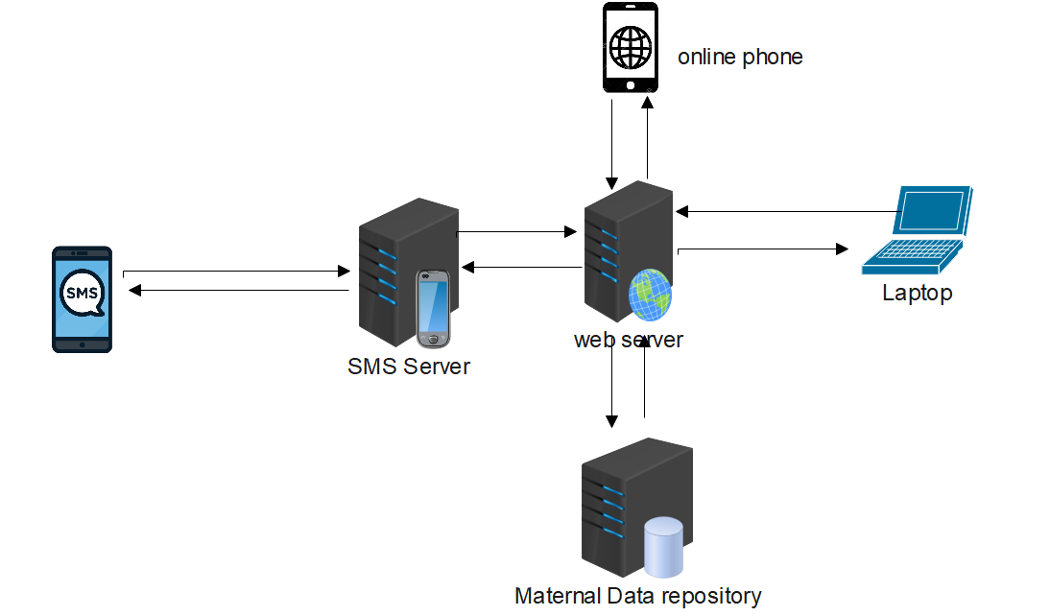

The diagram below shows how the system was decomposed giving a general understanding of how the individual subsystems work together

# 3. SYSTEM ARCHITECTURE

## 3.1 Architectural Design

The MMRPAS is to be implemented using a **repository architecture** as shown below.

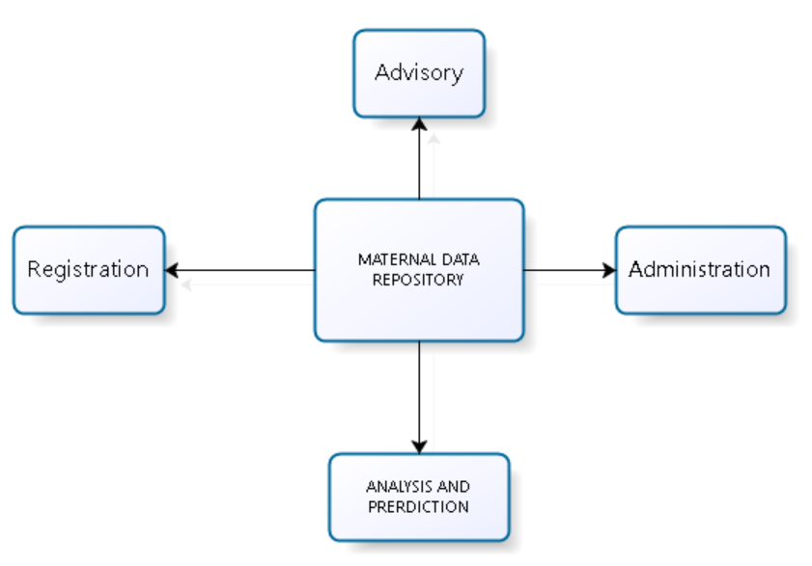

**Analysis and prediction model.**

Uses data from the data repository to make analysis and prediction.

**Administration model.**

The admin model uploads new dataset to a repository and also manages user accounts.

**Advisory model.**

The advisory subsystem uses data from the repository to offer advice to the pregnant mothers and health workers like the doctors.

## 3.2 Decomposition Description

The diagram below shows the functional decomposition description for MMRPAS, giving a general understanding of how the system will function.

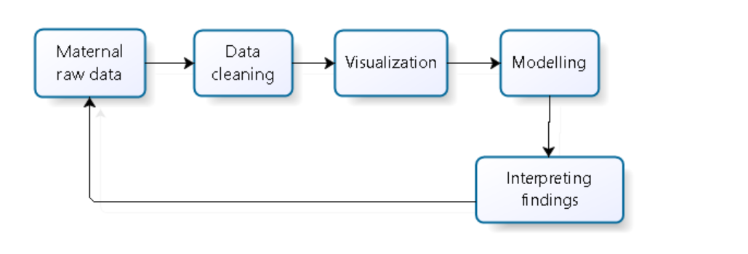

**Data visualization**

Data visualization is **the graphical representation of information and data**. By using visual elements like charts, graphs, and maps, data visualization tools provide an accessible way to see and understand trends, outliers, and patterns in data.

**Data modelling**

Data modelling in software engineering is the process of creating a data model for an information system by applying certain formal techniques

**Interpreting findings**

Interpreting findings is about seeing whether **what you found confirms** or does not confirm the findings of previous studies in your literature review. Your findings may also offer novel insights or information.

**Advisory subsystem**

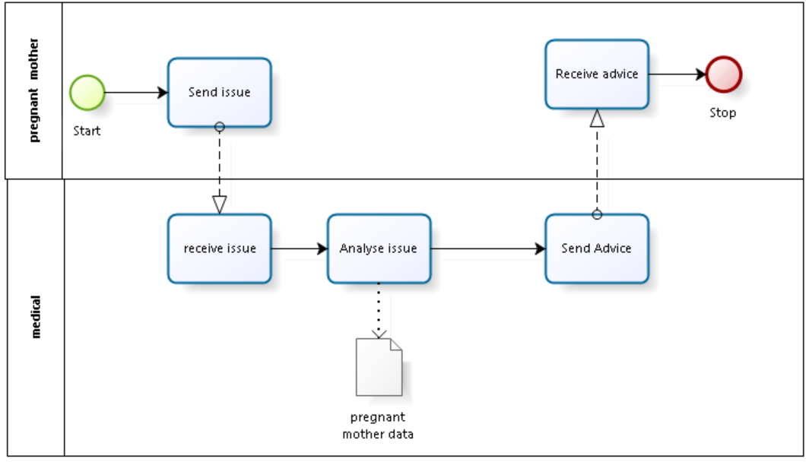

**Send issue.** The process starts by a pregnant mother sending a problem or an issue.

**Receive issue**. The medical system receives the issue

**Analyze issue**. The system analyses the issue basing on the data stored in the repository and **send advice** to the pregnant mother

The finally the pregnant mother will **receive advice** either SMS or mobile and email

**Lanes**

* Medical
* Pregnant mother

**Activities**

* Send issue
* Receive issue
* Analyse issue
* Send advice
* Receive advice

Data

* Pregnant mother data

## 3.3 Design Rationale

All data in a system is managed in a central repository that is accessible to all system components. Components do not interact directly, only through the repository.

We decided to use this architecture because

Components can be independent--they do not need to know of the existence of other components. Changes made by one component can be propagated to all components. All data can be managed consistently (e.g., backups done at the same time) as it is all in one place.

**With Client-server architecture**, each service is a single point of failure so susceptible to denial-of-service attacks or server failure. Performance may be unpredictable because it depends on the network as well as the system. May be management problems if servers are owned by different organizations.

**With Pipe and filter architecture**, the format for data transfer has to be agreed upon between communicating transformations. Each transformation must parse its input and unparsed its output to the agreed form. This increases system overhead and may mean that it is impossible to reuse functional transformations.

## 3.4 Design Patterns

This section defines the different software design patterns that will be adopted in the implementation of the MMRPAS. It depicts the structure of the design pattern as well as the reasons for its usage.

### 3.4.1 Model View Controller Pattern

This pattern will be used in the 3- tiered architectural pattern as defined in section 3.1 of this document. This pattern will be used to separate the application functionalities into three loosely-coupled components, the Model, the View and the Controller, thus rendering the entire application more maintainable. The model entails our file storage, the database and the MMRPAS neural model, the controller is the MMRPAS API and the view entails the web client.

### 3.4.2 Iterator Design Pattern

This design pattern will provide a way to access the elements of an aggregate object sequentially without exposing its underlying representation.

### 3.4.3 Singleton Design Pattern

This pattern is used to ensure that a class has only one instance and then provides a global point of access to it. It will also keep the instance we use as a cache object. This will be used to handle the database connection for the MMRPAS to avoid reloading the values each time the configuration parameters are used.

### 3.4.4 Adapter Design Pattern

This pattern is used to provide an interface to allow communication between incompatible interfaces. For example, in our MMRPAS, the adapter class will be used to allow communication between neural model object and the client objects.

### 3.4.4 The Object pool Design Pattern

This pattern offers a mechanism of reusing objects that are expensive to create. During software development, performance is a key issue and object creation is costly as well. This pattern will be used while creating a connection to the system database. This operation is expensive in such a way that opening too many connections might affect the MMRPAS performance for several reasons since the System database server will be overloaded.

# 4.DATA DESIGN

## 4.1 Data Description

## 4.2 Data Dictionary

|  |  |  |  |  |
| --- | --- | --- | --- | --- |
| **Table Name** | **Attribute name** | **Type** | **Size** |  |
| Maternal Registration | Name | Varchar | 30 |  |
| Location | Varchar | 30 |  |
| Pregnant status | Varchar | 40 |  |
| Hospital | Varchar | 30 |  |
| Age | Number | 10 |  |
| Contact | Varchar | 20 |  |
| Advisory table | Problem | Varchar | 100 |  |
| Solution | Varchar | 100 |  |
| New problem | Varchar | 100 |  |
| Approved | Boolean | 6 |  |
| Date | Date | 8 |  |
| Users | Name | Varchar | 30 |  |
| location | Varchar | 30 |  |
| Title | Varchar | 30 |  |
| contact | Varchar | 30 |  |
| Hospital | Varchar | 30 |  |
| Password | Password | 30 |  |

# 5.COMPONENT DESIGN

# 6.HUMAN INTERFACE DESIGN

Admin interface

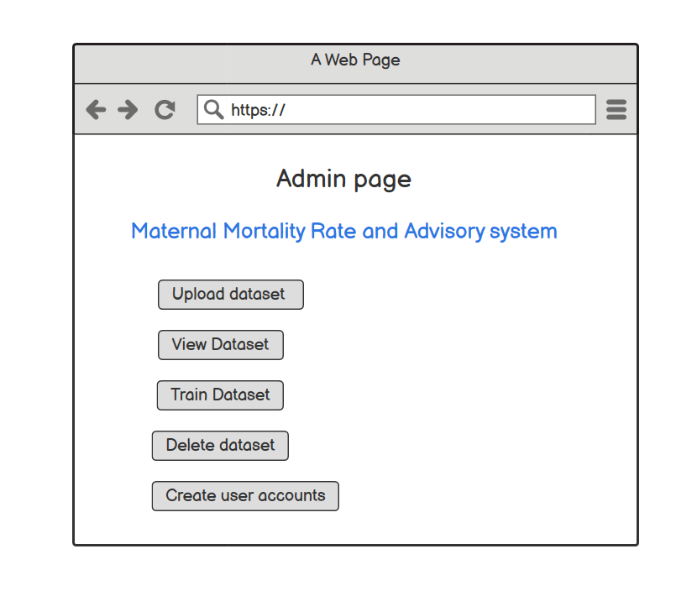

Doctor’s interface

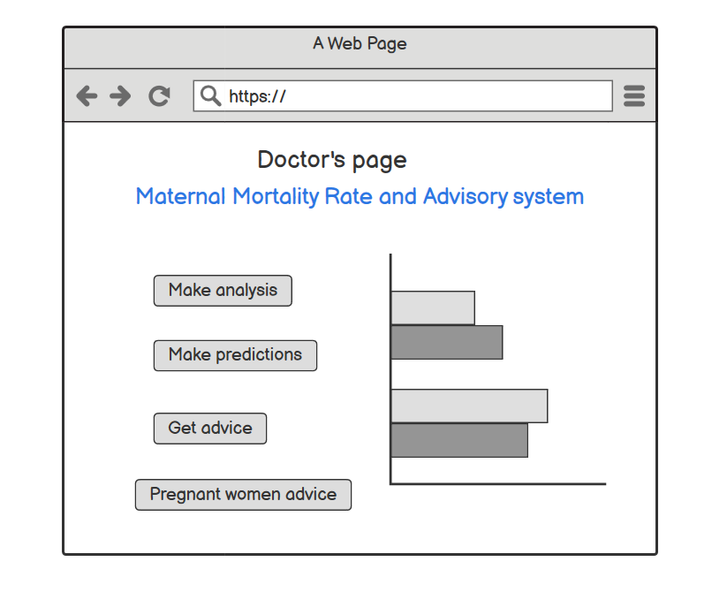

The System owners and Administrators shall interact with the system through a web-portal where the System owner should be able to register with Username and password on the web-portal to log in and manage the system information and an administrator also can be able to log in to the web-portal with a username and password where he/she can administer the system by for instance editing system or user information.

The dataset will be uploaded to the server through a web browser application.

The communication between the database, client application side and the web-portal consist of operation concerning reading and modifying data, while the communication between the application and database will be through reading only.

The communication between the phone and the server will through an SMS api that shall be uploaded on the server.

# REQUIREMENTS MATRIX